**The only difference or change I decided to make was fixing some awkward pauses and gaps in the audio that I did not notice at first in my final-for-now submission. I did this to refine the sound and quality of the episode/narrative/podcast.**

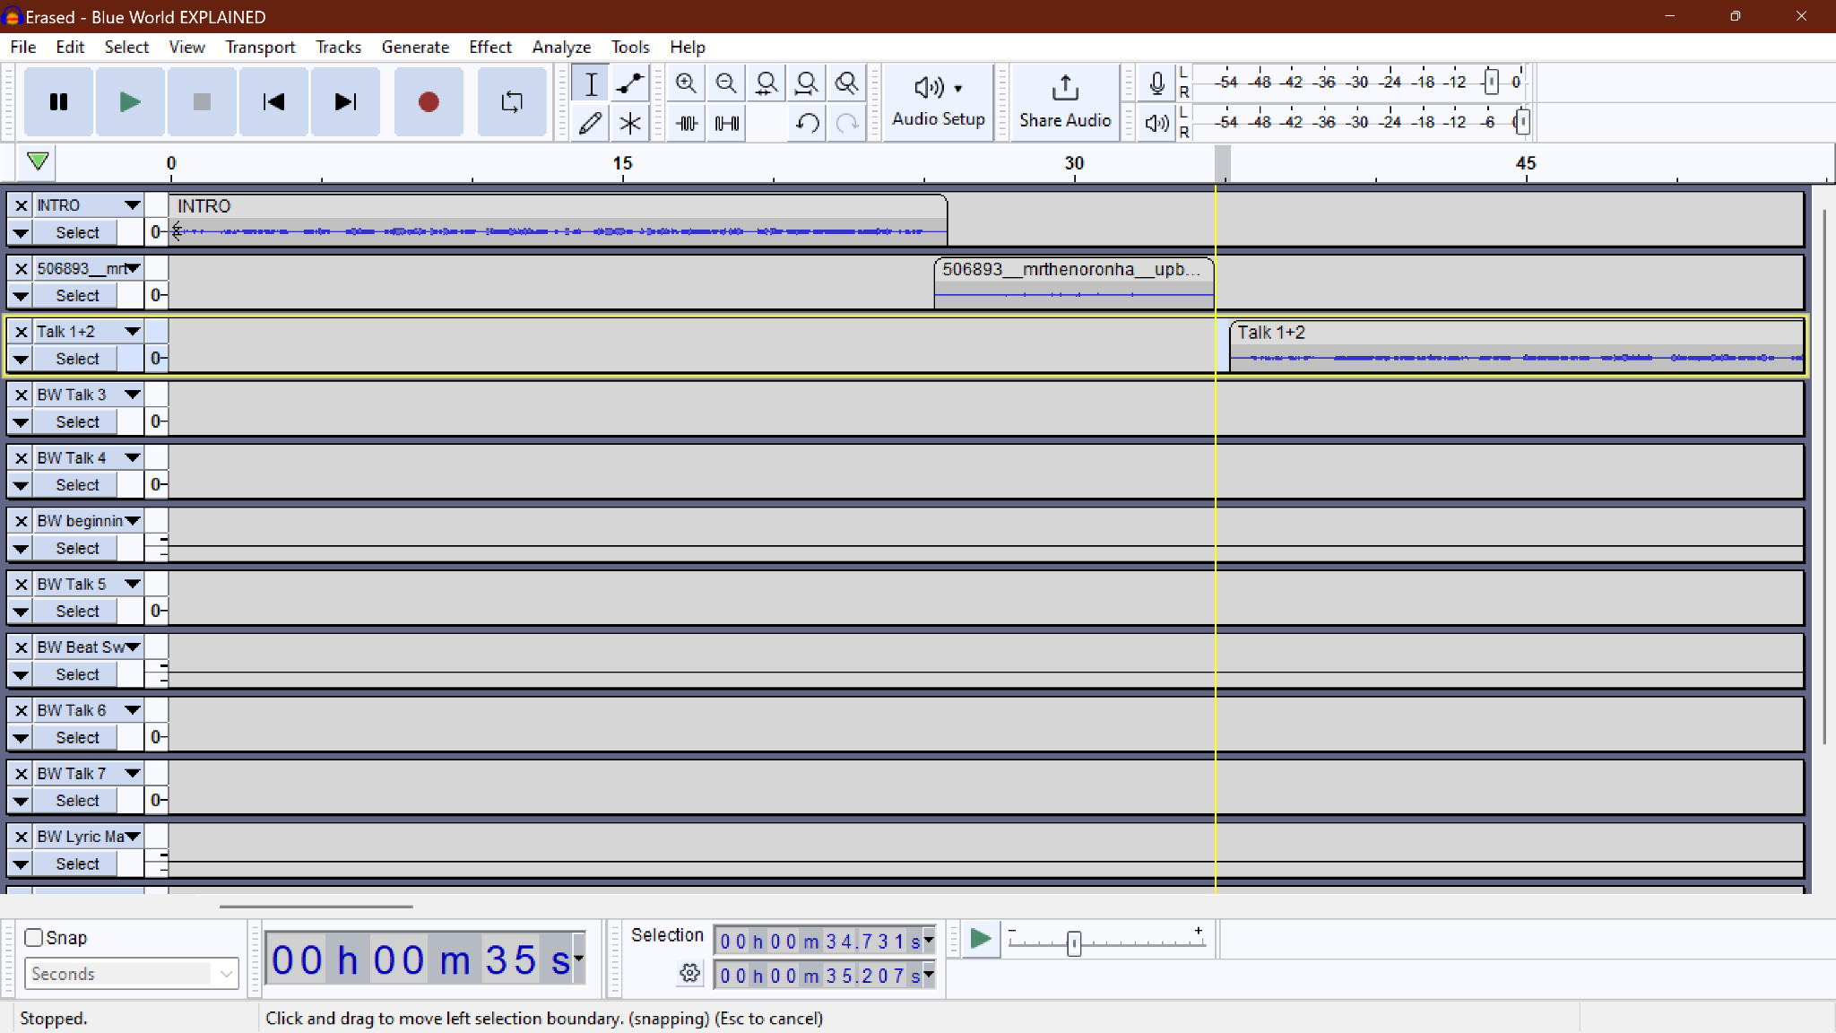

I knew that for my soundscape I wanted there to be spoken words, not just sounds and noises. I also love talking about things I’m passionate about, so I figured why not make a podcast. Some things that I love are music and anime. A couple of years ago, I found a way to combine those two interests of mine which was through video editing. I ended up making some anime edits or AMVs using music I loved and clips that I felt fit the scenes just right. It was a super enjoyable pastime of mine and being able to speak on it is something that also brings me joy. Conveying my thought process and what I imagine versus what came to be with someone is fulfilling for me.

I think I will explain the purpose of this soundscape narrative in the final product, so tune in to hear more about that. I do think it deserves some context though. I love watching a Youtube channel series called Genius VERIFIED ([https://www.youtube.com/playlist?list=PLlBiga-U14 ziDane-hqdxrWUItay0](https://www.youtube.com/playlist?list=PLlBigmhynF-U14eziDyn-hqdxrWUItay0)). In this segment they get artists to explain their songs and what went into making them and the stories behind the lyrics. I find it fascinating to get to see into others’ minds and what their imaginations hold.

In theory, I think you are supposed to have heard the song they are explaining at least once before watching them do a deep dive on it and the same can be said for my edit explanation episode. Everything would make sense if you watched the edit first (<https://www.youtube.com/watch?v=h183IJYrO4w>) and then listened to my episode. Without doing this, the listener would not be able to understand what I am referring to.

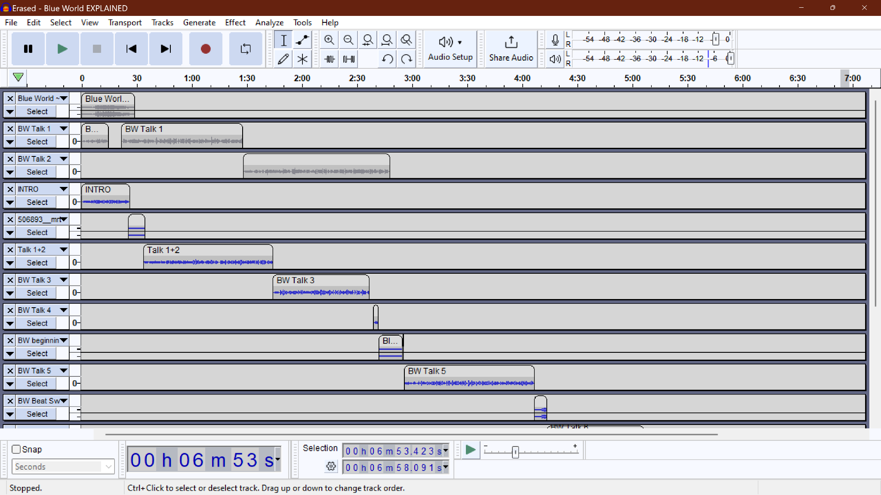

This screenshot is showing how I originally had things laid out in my rough draft. The first muted track is the audio of the song I refer to and use throughout the episode. The second muted track is my original intro and talking clip and the third muted track is another talking clip. These were deleted from the final draft because I wanted to try to keep my intro as brief and short as possible.

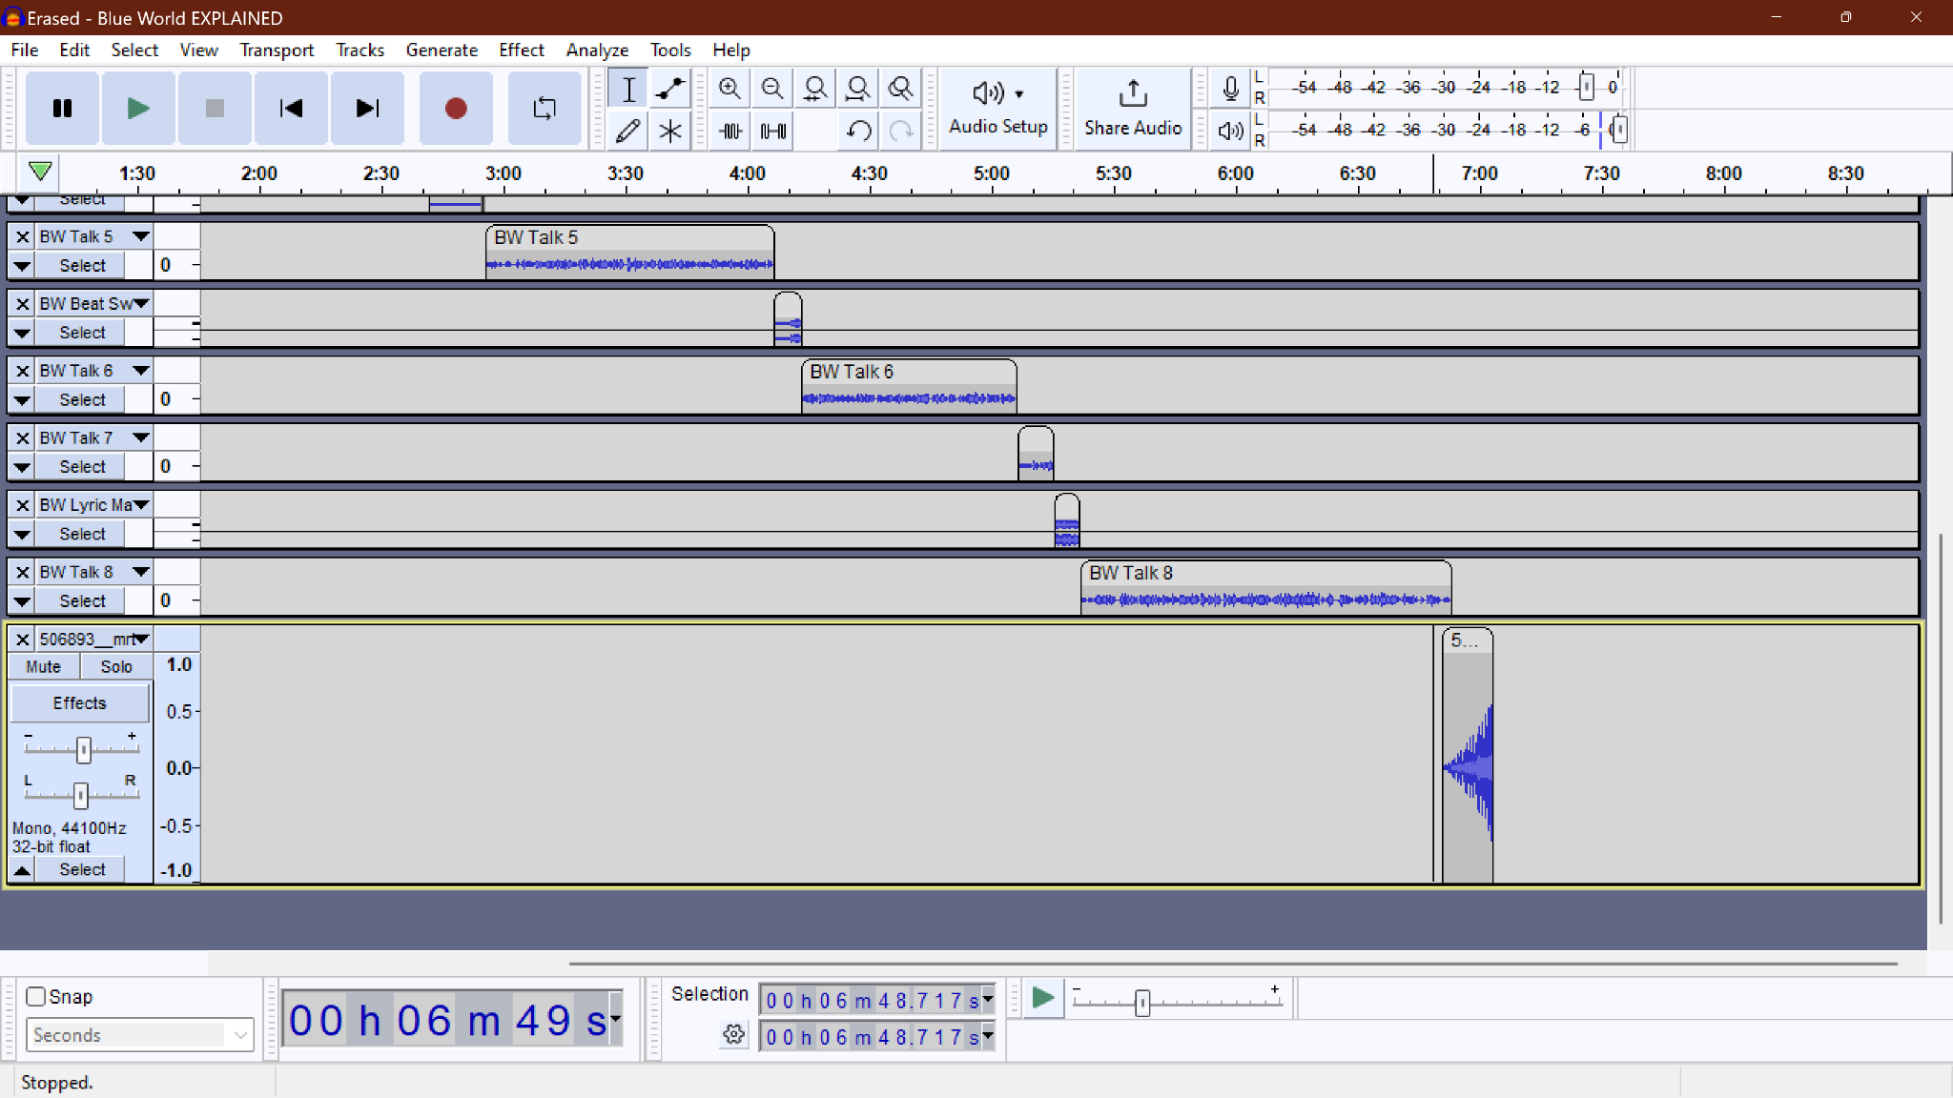

This shows the very last track I used. It was originally a stereo track that I split down into 2 identical mono tracks. I used one as an intro transition and the other as an outro transition sound. This is something that Genius does for all their VERIFIED videos so I wanted to have a similar element. I tested out multiple features on this last track such as fades, crossfading, and speed. I ended up ultimately going with the speed feature and slowed down this track. It is the same track as the intro transition but the slower speed in the end makes it different enough that it made the end more unique to me.

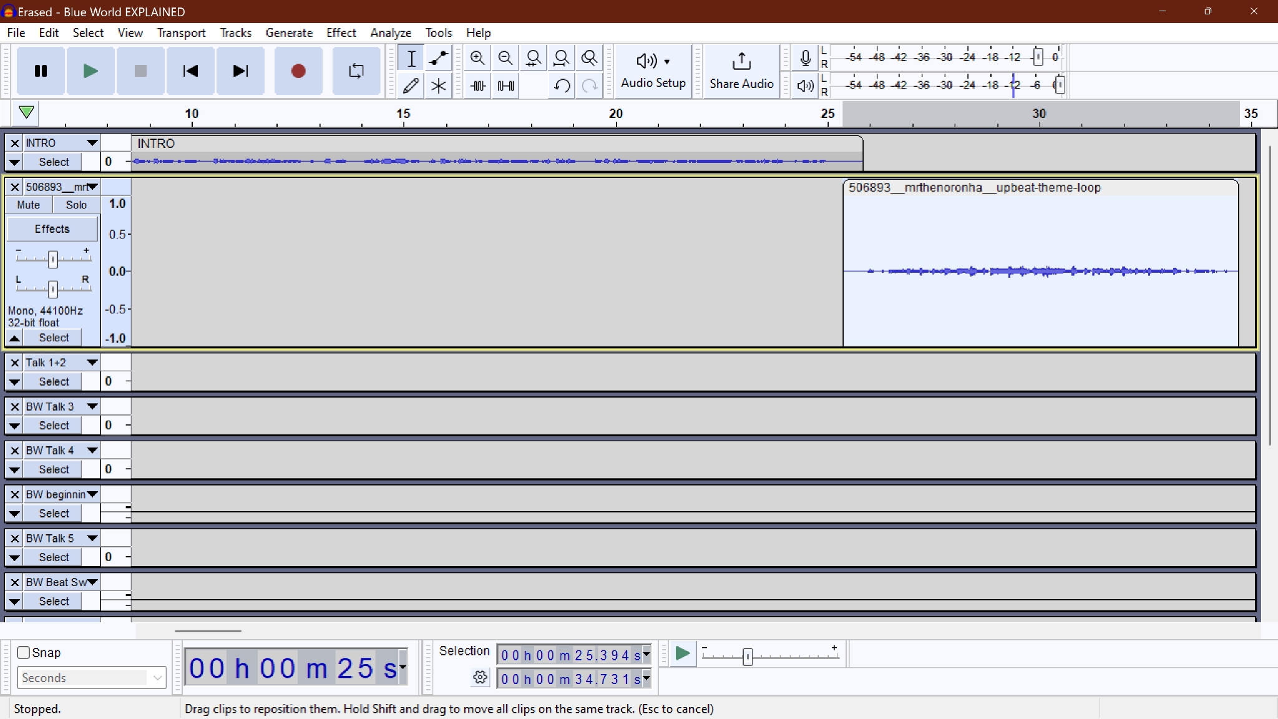

I used the fade in and out features on this track to make the transition between me speaking and this melody playing as seamless as possible.

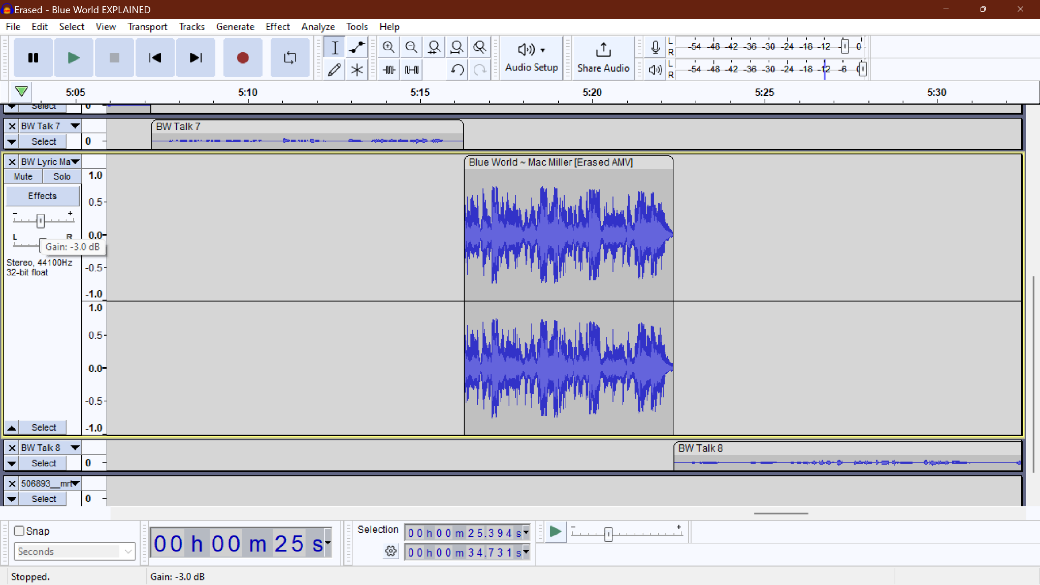

This screenshot is highlighting my use of gain. I played around with it quite a few times and tried my best to use it in a way that balanced the volume of different tracks as much as I could.

*SOURCES*

Blue World

Mac Miller

Youtube <https://www.youtube.com/watch?v=_GC2wFTCAGY>

WMG (on behalf of Warner Records Label)

Upbeat Theme Loop

MrtheNoronha

FreeSound <https://freesound.org/people/Mrthenoronha/sounds/506893/>

Attribution NonCommercial 4.0 License

The remainder of the tracks/sounds in this project were recorded by the creator (me).